# Protocol: Usage of R script ‘Multiplex Serology Dashboard.R’

## Description:

The R scripts, via a graphical user interface, can be used to merge the allocation plan and MFI values obtained from .csv files from Luminex and generates .xls files with the merged data. Files for sera and plate controls are generated separately.

Furthermore, a concatenated bead count file of all plates is calculated and provided as .xslx output files. The information stored in the bead count file is used to generate a warning file showing all wells and corresponding bead types for which the bead count was either too low or too high. Thresholds can be set by the user individually.

The script can be used with English or German annotations in .csv files and English or German excel versions.

## Possible scenarios:

Sera tested for one dilution can be processed directly. If there are deviations from the standard setting, contact Nicole Brenner **BEFORE** running the script.

The .csv files can include remeasurements for multiple wells. If a well is re-measured multiple times, then the final measurement must be in the highest numbered remeasurement.

# Script I (SAS1)

## Essential preconditions:

The names of the .csv files have to be adapted to the following nomenclature:

Normal: [Study name] Luminex [A,B,C,D,E] Platte [1-999].csv

e.g. Gö_Ha Tag 2 Luminex A Platte 16.csv

Remeasurement: [Study name] Luminex [A,B,C,D,E] Platte [1-999] R[1-999].csv

e.g. Gö_Ha Tag 2 Luminex A Platte 16 R1.csv

blanks: before Luminex, Luminex label, plate number, before well annotation, before the remeasurement number => no blanks before ".csv"

* Specification of Luminex label is essential for normalization of measurements by different devices

## Procedure:

### 1) Generate three folders: Raw Data, Organization and Analysis

* Copy .csv files to the folder "Raw Data" and rename the files if necessary
* Copy the excel file "Beads und Antigene" and "Plattenbelegung" to the Organization folder
* Copy the “Multiplex Serology Dashboard.R” file to the Analysis folder.

### 2) Verify the raw data files

* Check if the .csv files contain data
* If the plate was paused or ended early, ensure that the value for ‘Samples’ in Cell B21 matches the number of rows contained in the file, regardless if they have data or not.
* E.g. If the last row is A1, then Samples = 1. If the last row in the file in H12, then Samples = 96.

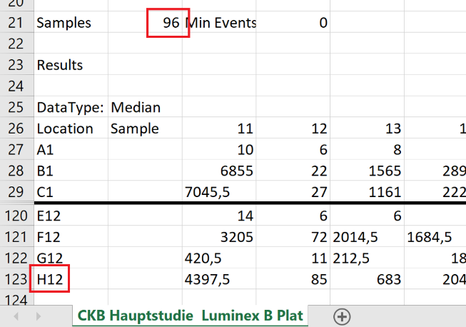

### 3) Adapt bead type list in excel file "Beads und Antigene"

* Sheet that contains bead types cannot include special characters or umlauts in naming.
* Columns must not start with a special character, umlaut or number.
* Header for the name column must be renamed into “Name”
* Header of bead type column must be renamed into either “Beadsorte”.
* Bead types are named from 1-100 => no "/"

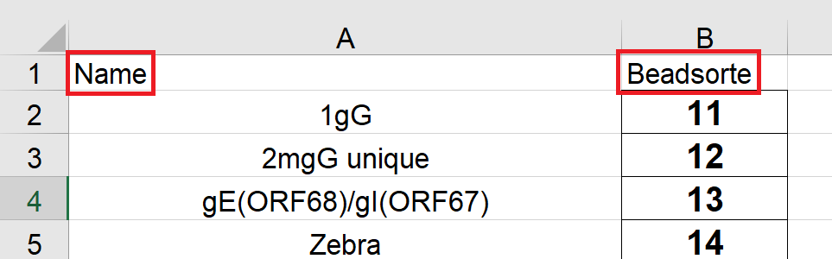

### 4) Adapt allocation plan in excel file "Plattenbelegung"

* Sheet that contains allocation plan must not include special characters or umlauts in naming.
* Columns must not start with a special character, umlaut or number.
* Unique identifiers must be renamed to column "fortNr". Otherwise no matching between MFI values and allocation plan is possible.
* Rows after the last fortNr must be empty.
* The unique sample ID must have the column name ”ID”
* All IDs for the controls must match, or they will not be included in the control sheet during output of Script II
* The empty well that is used for plate control must be named “Blank”
* Columns with the word “comment” included will be flagged as a warning in later steps

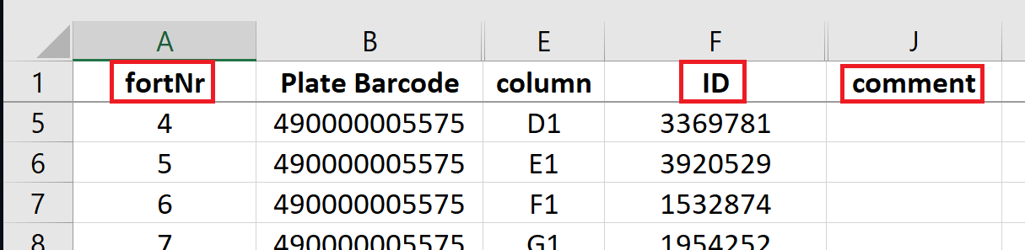

### 5) Locate and run the R scripts

* Open “Multiplex Serology.R” in RStudio and “Run App” button (at top of the editor)
* Input the .csv files, the allocation plan .XLSX file and worksheet, and the bead/antigen .XLSX file and worksheet
* Change any necessary options
  + Number of controls (default is 4)
  + GST Cutoff (default is 100) – values above this will be flagged as warnings
  + Row mean factor cutoff (default is 2) – row means < 2*empty mean value are flagged as warnings
  + Bead count cut-offs (default is 80,100,300,500) – hard cutoffs for bead count are first and last numbers, and middle two are the ‘maybe’ values. This affects the coloring of cells in the output.
* Press “Start Analysis”
* After processing, check the graphs for the bead count and MFI for anomalies
* Press “Export Excel file”

### 6) Control output:

The output .XLSX file is automatically opened in Excel. It will contain four worksheets:

* MFI: The luminex readings for the plates
* Bead count: The bead count for the plates
* Allocation Data: The data parsed from the allocation plan
* Excluded: The list of all wells that generated a warning
  + Warnings - Bead count above/below threshold, ID of “empty”/”leer”, missing bead measurement, or comments carried over from the allocation plan
  + Any measurement still present in the ‘Excluded’ sheet after analysis will not be included when running SAS2. Delete all lines from this sheet that you want included in the analysis
  + To remove further lines from analysis, **copy** and paste them from one of the other sheets. Only the fortNr is necessary for them to be excluded, so copying the entire row is not necessary

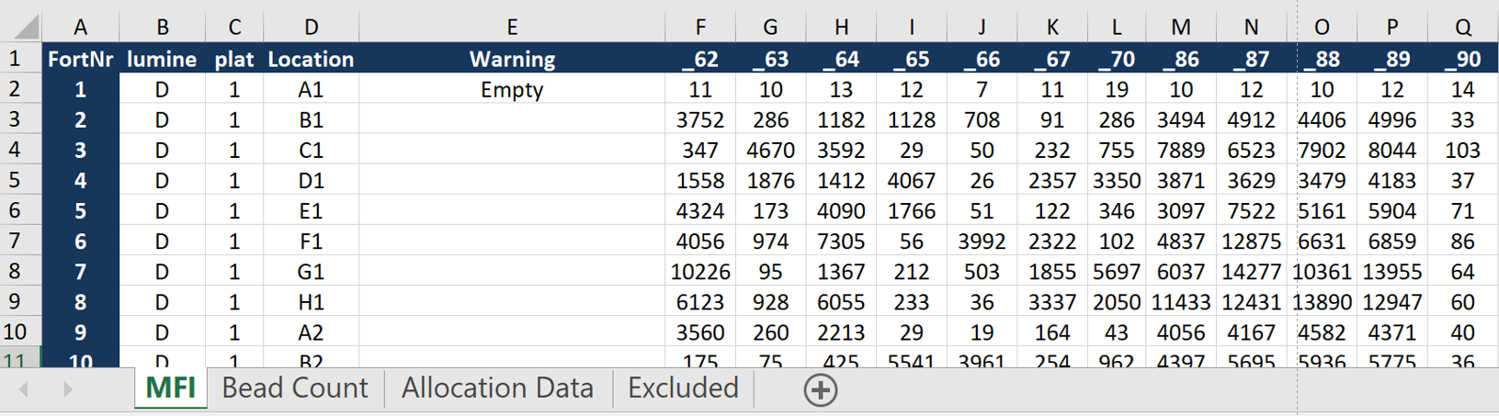

Before starting analysis:

* check if all sheets are generated
* check if all sheets contain data
* check if all plates are included + if MFI values / bead counts, bead types, fortNr are correct by checking first plate, one in the middle and the **last one**

# Script II (SASII)

## Essential preconditions:

Script I has run successfully and output an .XLSX file. Headers and sheet names in this file must not be modified, but new headers and sheets can be added without problem.

## Procedure:

### 1) Locate and run the R scripts

* Open “Multiplex Serology.R” in RStudio and “Run App” button (at top of the editor)
* Input the .XLSX file that was output from Script I.
* Change any necessary options
  + Net negative values – uses the actual value after GST background subtraction, instead of setting negative values at +1
  + Step-by-step calculation – outputs new worksheets for each calculation done in Script II: Raw Luminex Data, empty well subtraction, GST subtraction, and Luminex machine correction
* Press “Start Analysis”
* After processing, check the graphs for the bead count and MFI for anomalies
* Press “Export Excel file”

### 2) Control output:

The output .XLSX file is automatically opened in Excel. It will contain two worksheets:

* Sera: The net MFI measurements for all sera
* Control: The net MFI measurements for all control

If the step-by-step calculations is also selected, four additional worksheets will be included:

* Raw Luminex: The measurements as per the Luminex machines – no adjustment yet
* Minus BG: Raw MFI minus the empty well background
* Minus GST: Minus BG MFI values minus the GST background
* Machine Correction: Minus GST MFI values after correction for machine variances (Luminex machine B & D have a factor increase of 1.1)

Before starting analysis:

* check if all sheets are generated
* check if all sheets contain data
* check if all plates are included + if MFI values / bead counts, bead types, fortNr are correct by checking first plate, one in the middle and the **last one**

## Attention & Advice

* For serologies lasting several days, plate numbers need to be continuous.
* csv files need to be ";" delimited. If excel cannot separate columns open file in text editor. Replace "," by ";" and save file again.
* If any bead types were excluded from the measurement after x plates, the bead type has to be removed from every .csv file and from bead plan. Otherwise assignment of bead type and correct MFI values is not possible.
* Do not name header in allocation plan “plate”.
* If a serological experiment deviates from the standard setting, it is very likely that the R scripts are NOT able to process the data correctly. Please contact Nicole Brenner in such a case BEFORE running the scripts.

## Help

There are example folders containing one example each for the cases of a serology with one dilution and for a serology with two dilutions in:

U:\Labor Pawlita\Sero Projekte\ORGANISATION\SAS Analyse\Beispielordner_SAS_scripts

* These examples have been created for and with the old scripts for the old Luminex software.

If there are any problems, contact:

Nicole Brenner (nicole.brenner@dkfz-heidelberg.de)